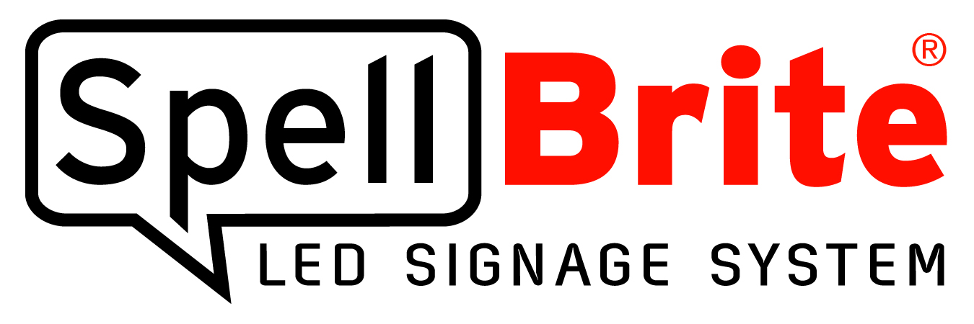

Contact:
Donald Tremblay
Phone 718-664-3405
dtremblay@earthlink.net

Press Release
Can’t Do That With Neon!
Merchants Eager for iLight's Portable
SpellBrite® LED Signage System and Battery Pack

"The original SpellBrite sign we hung in our restaurant window raised our lunch sales by over 20%. Making SpellBrite portable will help us sell even more.”

Chicago, IL - June 4, 2015: Merchants from a cross-section of industries who witnessed increased sales as a result of SpellBrite's window signage system are eager to purchase SpellBrite's new portable signage system and battery-pack, it was announced today by iLight President Sean Callahan. "Business owners in industries as diverse as food service, automotive, convenience, and even face painting were so pleased with the 10-30% increase in sales from our original SpellBrite signage system that when they heard iLight was creating a portable SpellBrite system with a battery-pack, they jumped at the opportunity to add it to their marketing plans. As a result we began a Kickstarter campaign to fund the battery-pack and it has already surpassed our financial goal."

SpellBrite’s Kickstarter campaign was originally scheduled for 45 days with a goal of $45,000. However, because of the investment already made in the project plus the addition of a supplier that will amortize much of the fixed costs, iLight was able to reduce the Kickstarter goal to only $2,500. Since the financial goal of a Kickstarter campaign cannot be altered once active, iLight closed its original campaign and began a brand-new 30-day campaign on May 22, 2015. With 2/3 of the campaign remaining, the $2,500 goal has already been nearly doubled. (http://kck.st/1doC2Ki)

Shaun Kanchwala of Taylor Street Pizza in Carpentersville, IL is a prime example of a business owner who is interested in SpellBrite's new portable system because of the increased profits his business earned as a result of advertising with SpellBrite's original signage system. In 2014, Kanchwala faced unexpected increased costs and was forced to consider a group of difficult choices: use cheaper ingredients, accept reduced profits, or increase prices and risk losing customers. "If you think about it, I really had no alternative,” said Kanchwala. “Lower food quality and you are sure to lose customers. Continually accept reduced profits and you go out of business. I had to raise prices, but I also had to do it in a way that would minimize customer defections.”

Kanchwala raised his prices but simultaneously added SpellBrite's signage system to his windows to advertise his specials. The result? Not only did unit sales not drop, his sales revenue increased over 20%. The increased sales made a believer out of Kanchwala, and now he plans to use SpellBrite's portable system to further market his business. “We are excited about the new SpellBrite portable battery pack option. Now we can hang an ultra-bright SpellBrite sign in our Taylor Street Pizza booth at local fairs and festivals. With SpellBrite, our special combo offers are sure to stand out and generate more sales.”

SpellBrite's portable system allows individuals and businesses to express themselves using an environmentally-friendly "click-together" set of LED battery-operated characters that has the striking, bright look of neon without the dangers and risks inherent with glass neon construction. SpellBrite's 44 letters, numbers and characters are interchangeable, allowing anyone to create an ultra-bright message that can be changed at any time. SpellBrite signs are lightweight and durable – a typical 10 character sign weighs less than 3 pounds. With a battery pack, the user can take a SpellBrite sign virtually anywhere: parties, sporting events, rallies, parades, concerts, tailgating, and more.

SpellBrite was born from the technology developed by iLight Technologies, a pioneer and leader in innovative LED illumination solutions. Founded in 1999, the company’s award-winning legacy of exceptional lighting products are known for their high brightness and smooth even glow. The company currently holds more than 100 patents in the U.S. and international markets. SpellBrite was introduced in 2012. Retailers and restaurant owners quickly grasped the benefits of the signage system; SpellBrite was named a Retailer Top Pick at the 2012 NACS trade show and Best New Product at the 2012 ISA International Sign Expo. In 2013 iLight received the Chicago Innovation Award for SpellBrite.

Website: www.SpellBrite.com
Kickstarter: http://kck.st/1doC2Ki
Twitter: https://twitter.com/SpellBrite
Facebook: https://www.facebook.com/SpellBrite
Google Plus: https://plus.google.com/105812370251068213042/posts
Instagram: https://instagram.com/SpellBrite

